Chemistry 4612

Due 2/3/21

1. For each molecule below, list the types of supramolecular interactions in which it could participate with Na+ (sodium cation)

(a) Cl- (chloride anion)

(b) CH4

(c) chlorobenzene

2. Explain the difference between a cation- and a - interaction and give an example of each.

3. Sketch the arrangement of water molecules around a sodium ion and around a chloride ion. Explain the different orientations of the water molecules and label all the atoms with either full or partial charges.

4. Which pair of molecules has a stronger interaction, explain your choice:

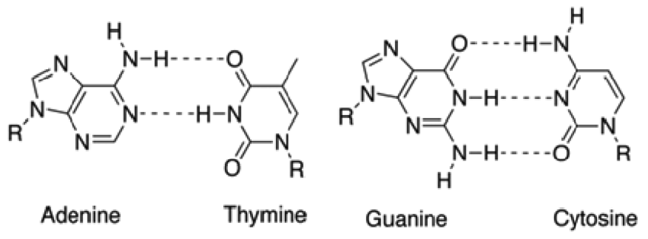

5. Which molecule, when dispersed in water, at a concentration where micelles form, would have a greater hydrophobic effect, and explain your choice. Make a small sketch of the structure of a micelle.

(a) sodium octyl sulfate

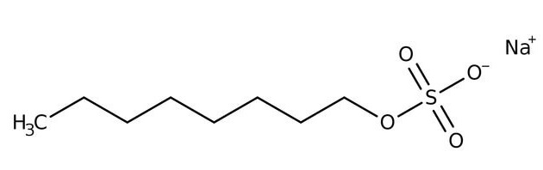

(b) sodium dodecyl sulfate

